Type fdatool in the command window to start
Choose the following:
Response Type
Choose Fs, Passband & Stopband frequency,
Magnitude specifications : Passband=1 and Stopband =60
Set filter order to minimum ( if applicable)
Set density factor to 16 ( if applicable)
Click on Design filter

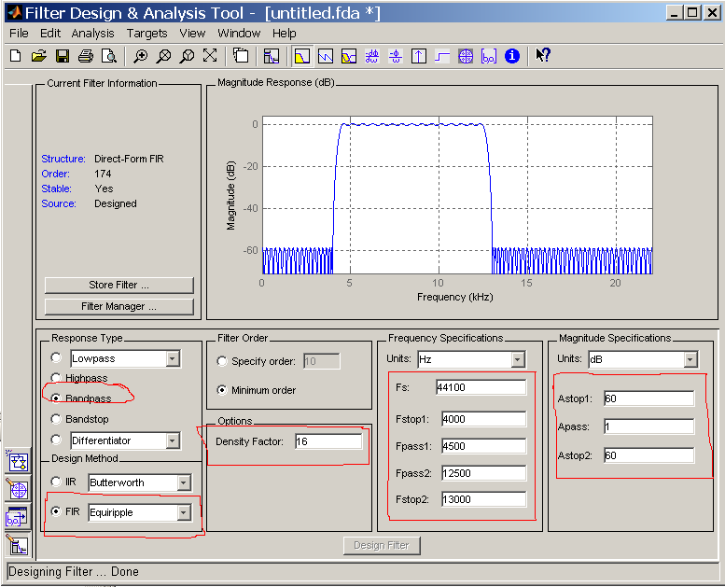
Exporting:

FIR filter:
An FIR design only generates Num parameters. Under File, select Export. This will produce the Export window. Make sure that Export To is set to MAT-file, select a file name (choose a unique filename), and then save the file.

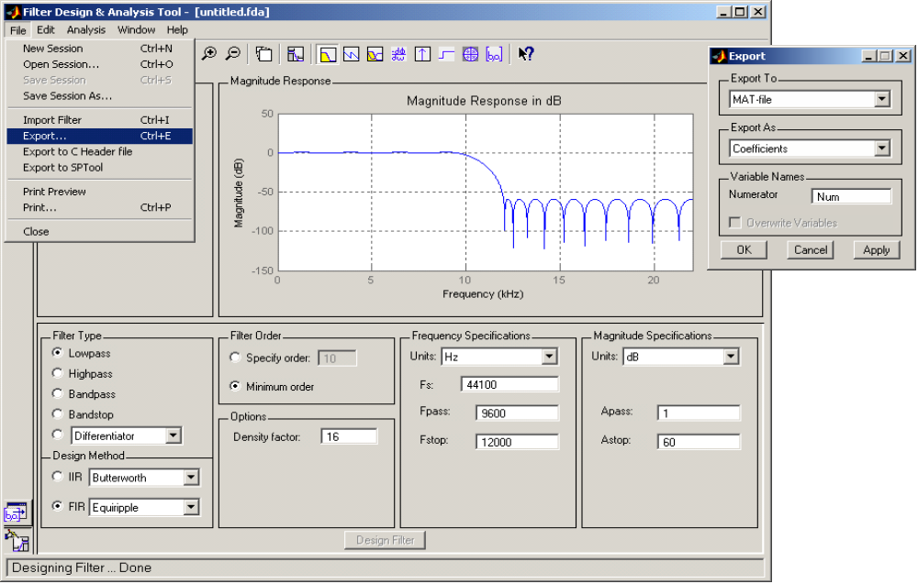

IIR filter:

An IIR design generates both Num and Den parameters; to ensure that the saved parameters are in this form, under Edit select Convert to Single Section. After this, follow the same export procedures as for the FIR design.

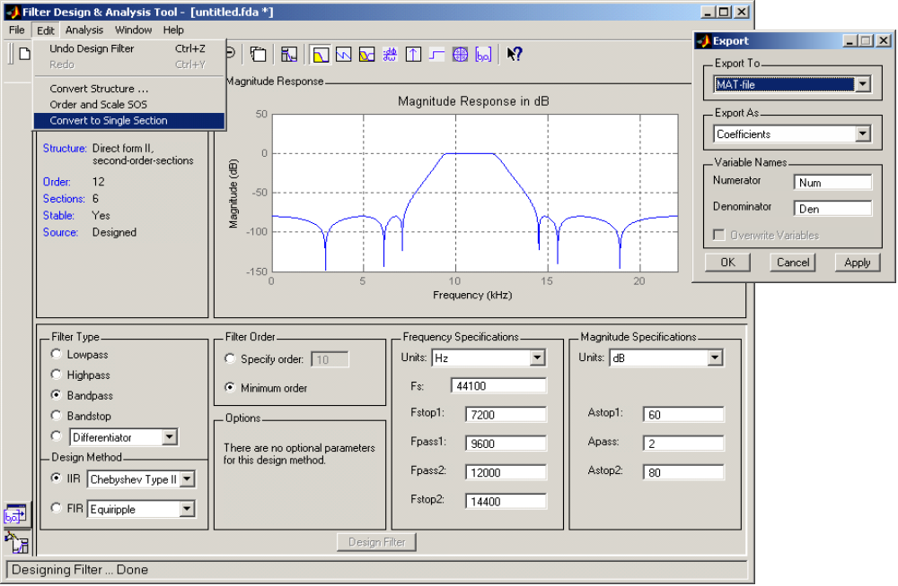

load example_data2008.mat
time_freq_plot(y,512,Fs)

load bpf34b
filt1=filter(Num3,1,y);
time_freq_plot(filt1,512,Fs)

